## 

## **Experiment-10**

**Student Name:** Gauri Prabhakar **UID:** 18BCS6201

**Branch:** 18AITAIML-2 **Section/Group:** B

**Semester:** 7 **Date of Performance:** 17h November, 2021

**Subject Name:** Advanced Database Management Lab **Subject Code:** CSP - 434

# Aim/Overview of the practical:

To implement a Case Study on Functional dependency with examples for redundant functional dependencies

# Task to be done:

To implement a Case Study on Functional dependency with examples for redundant functional dependencies

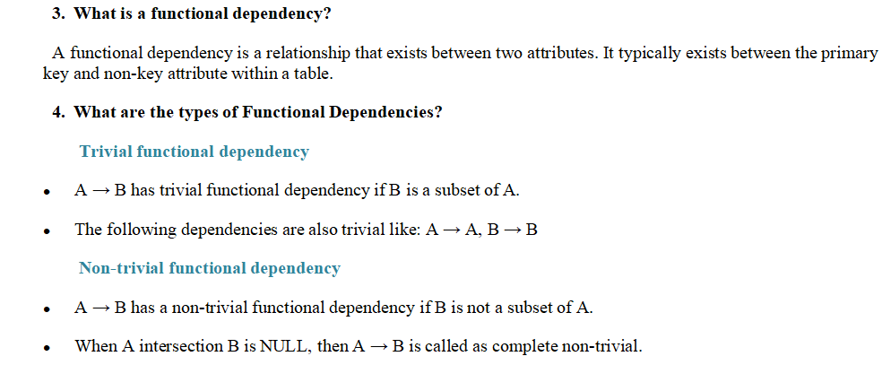

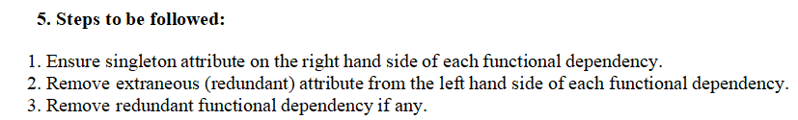

1. **Example:**

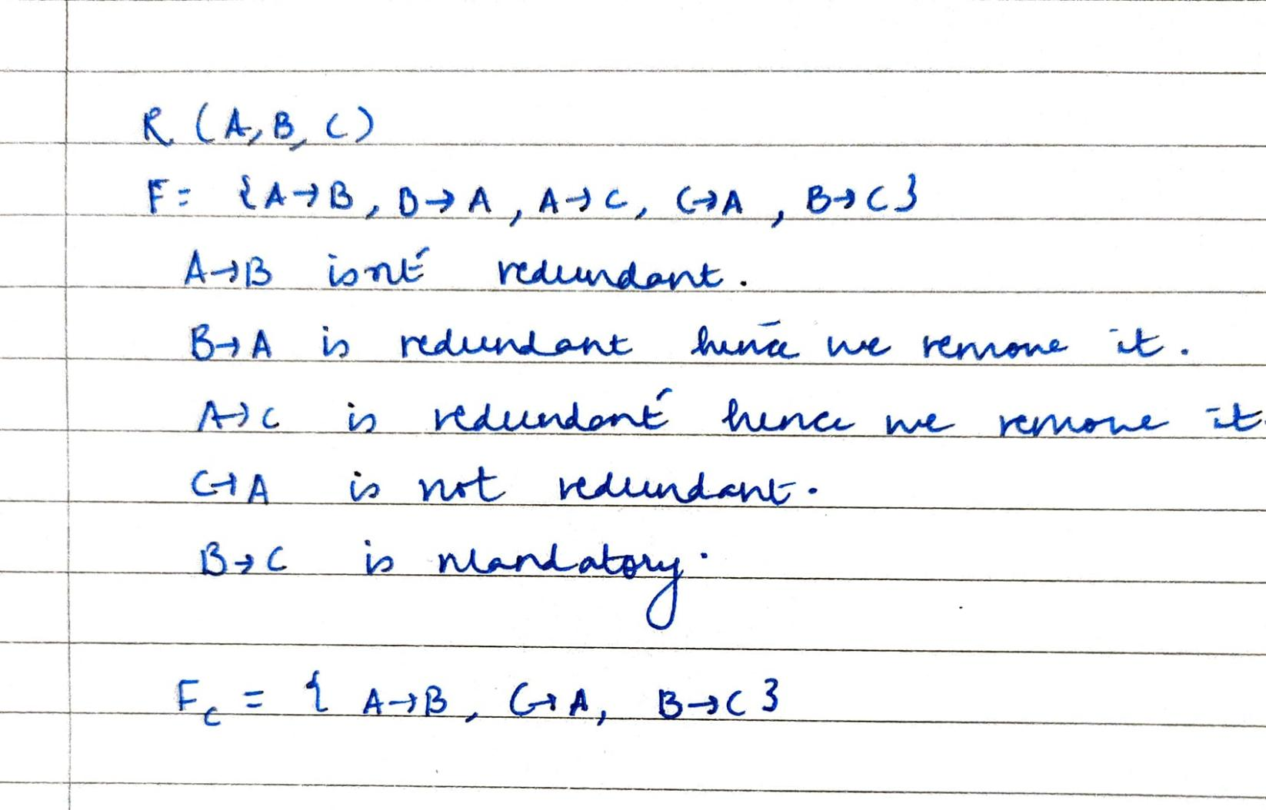

1. **Result/Output/Writing Summary:**

* Successfully implemented FUNCTIONAL DEPENDENCIES.
* Successfully implemented removing FUNCTIONAL DEPENDENCIES.
* Successfully understood the functioning and importance of the above mentioned.

# Learning outcomes (What I have learnt):

* How to implement MINIMAL CLOSURE.
* How to implement FUNCTIONAL DEPENDENCIES.
* How to implement removal FUNCTIONAL DEPENDENCIES.

**Evaluation Grid (To be created as per the SOP and Assessment guidelines by the faculty):**

|  |  |  |  |
| --- | --- | --- | --- |
| Sr. No. | Parameters | Marks Obtained | Maximum Marks |
| 1. |  |  |  |
| 2. |  |  |  |
| 3. |  |  |  |